EENG 284

–

Digital Design Lab

Lab10

–

Stopwatch Control Unit

Lab Solutions

Completed Table 1

Table 1: Control word table for the stopwatch finite state machine shown in Figure 3.

|  |  |  |  |  |  |
| --- | --- | --- | --- | --- | --- |
|  | cw[5]  2x1 mux | cw[4]  lap register | cw[3]  mod 10 reset | cw[2]  mod10 count | cw[1:0]  timer counter |
|  | 0 = mod10 | 1 = load | 1 = reset | 1 = count up | 11 = load |
|  | 1 = register | 0 = hold | 0 = hold | 0 = hold | 10 =count up |
|  |  |  |  |  | 01 = not used |
|  |  |  |  |  | 00 = hold |
| RESET | 0 | 0 | 1 | 0 | 11 |
| STOP | 0 | 0 | 0 | 0 | 00 |
| S2RES | 0 | 0 | 0 | 0 | 00 |
| S2R | 0 | 0 | 0 | 0 | 00 |
| RUN | 0 | 0 | 0 | 0 | 10 |
| R2LR | 0 | 1 | 0 | 0 | 00 |
| R2S | 0 | 0 | 0 | 0 | 00 |
| INC | 0 | 0 | 0 | 1 | 11 |
| LAPRUN | 1 | 0 | 0 | 0 | 10 |
| LR2R | 1 | 0 | 0 | 0 | 00 |
| LR2LS | 1 | 0 | 0 | 0 | 00 |
| LAPINC | 1 | 0 | 0 | 1 | 11 |
| LAPSTOP | 1 | 0 | 0 | 0 | 00 |
| LS2R | 1 | 0 | 0 | 0 | 00 |
| LS2LR | 1 | 0 | 0 | 0 | 00 |

Completed Figure 6 through Figure 9.

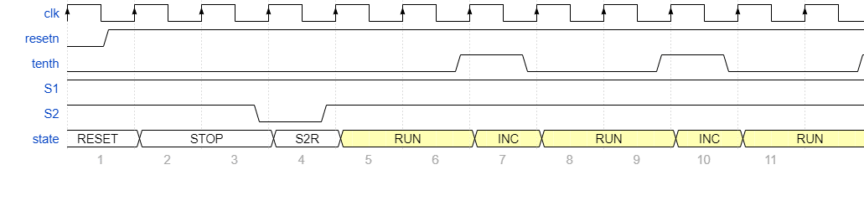

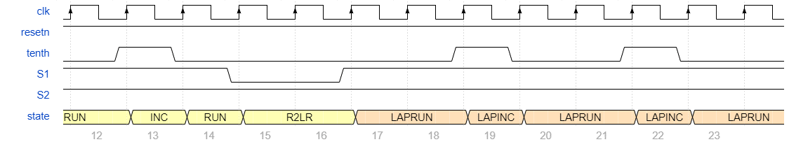

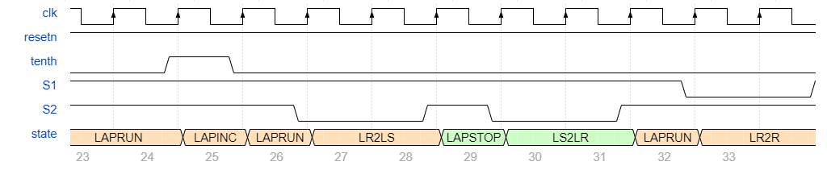

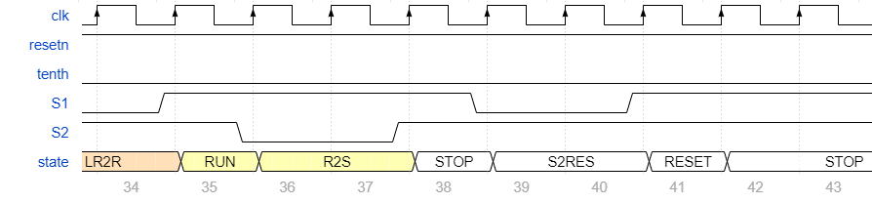

module controlUnit(clk, resetn, cw, sw);

parameter SW_VECTOR_LENGTH = 3;

parameter CW_VECTOR_LENGTH = 6;

input wire clk, resetn;

output reg [CW_VECTOR_LENGTH - 1 : 0] cw;

input wire [SW_VECTOR_LENGTH - 1 : 0] sw;

wire tenth, S1, S2;

reg [3:0] state;

reg [3:0] nextstate;

localparam RESET_CW = 6'b001011;

localparam STOP_CW = 6'b000000;

localparam S2RESET_CW = 6'b000000;

localparam S2R_CW = 6'b000000;

localparam RUN_CW = 6'b000010;

localparam R2LR_CW = 6'b010000;

localparam R2S_CW = 6'b000000;

localparam INC_CW = 6'b000111;

localparam LAPRUN_CW = 6'b100010;

localparam LR2R_CW = 6'b100000;

localparam LR2LS_CW = 6'b100000;

localparam LAPINC_CW = 6'b100111;

localparam LAPSTOP_CW = 6'b100000;

localparam LS2R_CW = 6'b100000;

localparam LS2LR_CW = 6'b100000;

parameter RESET_STATE = 4'b0000,

STOP_STATE = 4'b0010,

S2RESET_STATE = 4'b0001,

S2R_STATE = 4'b0011,

RUN_STATE = 4'b0100,

R2LR_STATE = 4'b0110,

R2S_STATE = 4'b0101,

INC_STATE = 4'b0111,

LAPRUN_STATE = 4'b1000,

LR2R_STATE = 4'b1001,

LR2LS_STATE = 4'b1010,

LAPINC_STATE = 4'b1011,

LAPSTOP_STATE = 4'b1100,

LS2R_STATE = 4'b1101,

LS2LR_STATE = 4'b1110;

assign tenth = sw[0];

assign S1 = sw[1];

assign S2 = sw[2];

// Take care of reset logic

always @(negedge resetn, posedge clk)

if (!resetn)

state <= RESET_STATE;

else

state <= nextstate;

// Determine the output

always @(state) // always block to compute output

begin

case(state)

RESET_STATE: cw = RESET_CW;

S2RESET_STATE: cw = S2RESET_CW;

STOP_STATE: cw = STOP_CW;

s2R_STATE: cw = S2R_CW;

RUN_STATE: cw = RUN_CW;

R2LR_STATE: cw = R2LR_CW;

R2S_STATE: cw = R2S_CW;

INC_STATE: cw = INC_CW;

LAPINC_STATE: cw = LAPINC_CW;

LAPRUN_STATE: cw = LAPRUN_CW;

LR2R_STATE: cw = LR2R_CW;

LR2LS_STATE: cw = LR2LS_CW

LAPSTOP_STATE: cw = LAPSTOP_CW;

LS2R_STATE: cw = LS2R_CW;

LS2LR_STATE: cw = LS2LR_CW;

default: cw = RESET_CW;

endcase

end

//------------------------------------------

// Determine the next state

// buttons are logic 0 when pressed

//------------------------------------------

always @(*) // always block to compute nextstate

begin

case(state)

RESET_STATE:

nextstate = STOP_STATE;

STOP_STATE:

begin

case({S2,S1})

2'b10: nextstate = S2RESET_STATE;

2'b01: nextstate = S2R_STATE;

default: nextstate = STOP_STATE;

endcase

end

S2RESET_STATE:

begin

case (S1)

1'b1: nextstate = RESET_STATE;

default: nextstate = S2RESET_STATE;

endcase

end

S2R_STATE:

begin

case(S2)

1'b1: nextstate = RUN_STATE;

default: nextstate = S2R_STATE;

endcase

end

RUN_STATE:

begin

case({tenth, S2, S1})

3'b111: nextstate = INC_STATE;

3'b010: nextstate = R2LR_STATE;

3'b001: nextstate = R2S_STATE;

default: nextstate = RUN_STATE;

endcase

end

R2LR_STATE:

begin

case(S1)

1'b1: nextstate = LAPRUN_STATE;

default: nextstate = R2LR_STATE;

endcase

end

R2S_STATE:

begin

case(S2)

1'b1: nextstate = STOP_STATE;

default: nextstate = R2S_STATE;

endcase

end

INC_STATE:

begin

nextstate = RUN_STATE;

end

LAPRUN_STATE:

begin

case({tenth, S2, S1})

3'b111: nextstate = LAPINC_STATE;

3'b010: nextstate = LR2R_STATE;

3'b001: nextstate = LR2LS_STATE;

default: nextstate = LAPRUN_STATE;

endcase

end

LR2R_STATE:

begin

case(S1)

1'b1: nextstate = RUN_STATE;

default: nextstate = LR2R_STATE;

endcase

end

LR2LS_STATE:

begin

case(S2)

1'b1: nextstate = LAPSTOP_STATE;

default: nextstate = LR2LS_STATE;

endcase

end

LAPINC_STATE:

begin

nextstate = LAPRUN_STATE;

end

LAPSTOP_STATE:

begin

case ({S2, S1})

2'b10: nextstate = LS2R_STATE;

2'b01: nextstate = LS2LR_STATE;

default: nextstate = LAPSTOP_STATE;

endcase

end

LS2R_STATE:

begin

case(S1)

1'b1: nextstate = RESET_STATE;

default: nextstate = LS2R_STATE;

endcase

end

LS2LR_STATE:

begin

case (S2)

1'b1: nextstate = LAPRUN_STATE;

default: nextstate = LS2LR_STATE;

endcase

end

default: nextstate = RESET_STATE;

endcase

end

endmodule

* Produce a timing diagram with the following characteristics. Zoom to fill the available horizontal space with the waveform.

